

Mohd Nawaz Hussain

**MANAGING & PROGRAMMING DATABASE**

**Trishla Shah**

**ASSIGNMENT 04**

**11/11/2018**

**Group Members:**

**Mohd Nawaz Hussain (A00428036)**

**Bhagya Sharma (A00431152)**

**Rishab Gupta (A00429019)**

**Madeleine Leong (A00430926)**

## Running bash script

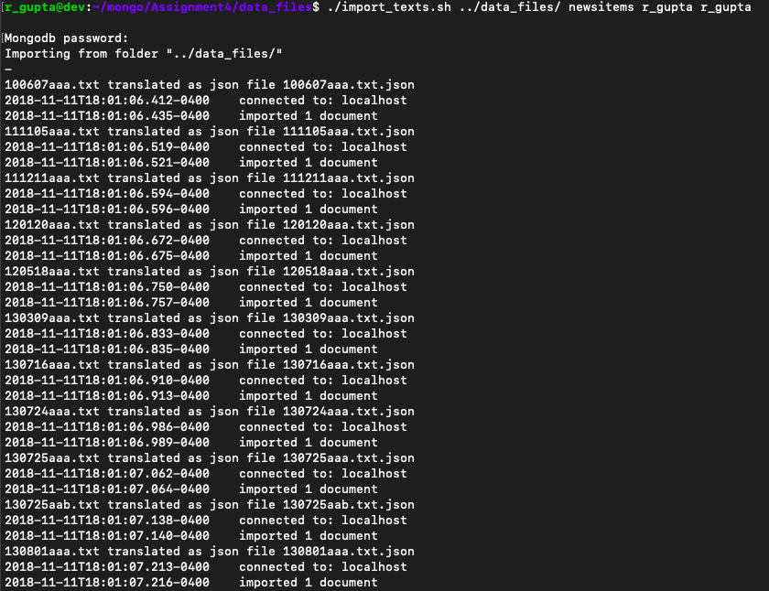

## 

## Query

## 

## References

Dane, Mike. “Text Indexing | MongoDB | Tutorial 9.” YouTube, YouTube, 22 Dec. 2017, [www.youtube.com/watch?v=dTN8cBDEG_Q](http://www.youtube.com/watch?v=dTN8cBDEG_Q)